 | Course Name: Advanced Web Technology | EXPERIMENT NO. 2
 | Course Code: 20CP314P Faculty: Komal Singh | Branch: CSE | Semester: VI
Submitted by: Harsh Shah
Roll no: 21BCP359

Objective: Building a Web Server with Express.js
Experiment 2: Implement with routing methods (GET and POST) and also implement one built-in middleware, configurable middleware and one third party middleware (Cookie-Parser).
Hint: You can also use the function validate cookie in third party middleware.
App.js
const express = require('express');
const cookieParser = require('cookie-parser'); const app = express(); app.use(express.json());
app.use(express.urlencoded({ extended: true })); app.use(cookieParser());

// Configurable middleware
const myMiddleware = (config) => { return (req, res, next) => {
console.log(`Configurable Middleware: ${config}`); next();
};
};
// GET route
app.get('/', (req, res) => { res.send('Hello, this is a GET route!');
});
// POST route with configurable middleware and cookie handling app.post('/', myMiddleware('I am configurable middleware'), (req, res) => {
console.log('Request Body:', req.body);

// Set a cookie
res.cookie('myCookie', 'cookieValue');
// Retrieve and validate the cookie const myCookie = req.cookies.myCookie; if (myCookie === 'cookieValue') {
res.send('Hello, this is a POST route! Cookie is valid.');
} else {
res.send('Hello, this is a POST route! Cookie is invalid.');
}
});
const PORT = 3000; app.listen(PORT, () => {
console.log(`Server is running on http://localhost:${PORT}`);
});

Output :-
Get Request :-
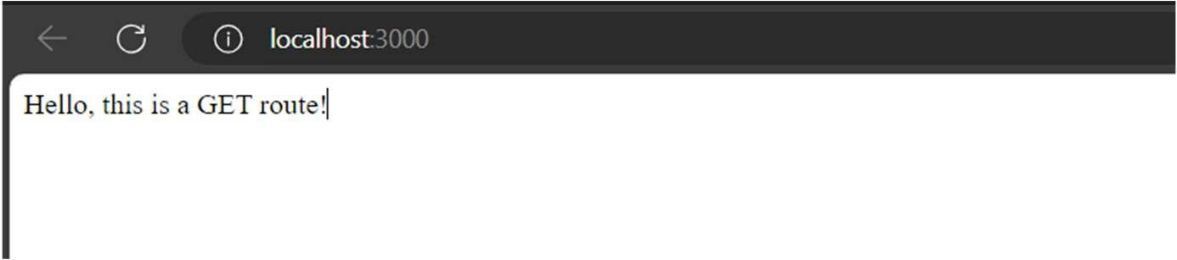
Post Request With Cokkie-parser :-
